

Practical No. : 1
Aim -
Demonstrate inline, internal, and external JavaScript; use console methods; create a webpage showing user info and a welcome message.
Software/Tools Required –
VSCode, Chrome, HTML5, CSS3, Javascript (ES6)
Experiment Program Code –
index.html
<html>
<head>
<title>
js lec1
</title>
<script>
function showWelcome() {
let name = document.getElementById("name").value;
let age = document.getElementById("age").value;

document.getElementById("output").innerHTML =
"<h2> Welcome, " + name + "!</h2>" + "<p> Your age is : " + age + "</p>";

console.log("User name : " + name);
console.info("User Age : " + age);
console.warm("This is a warning message");
console.error("This is a error message ");
}
</script>
</head>

<body>
<h1>User Info</h1>
<h4> Enter your name </h4>
<input type="text" id="name" placeholder="Enter name">
<h4>Enter your age </h4>
<input type="number" id="age" placeholder="Enter age">

<button onclick="showWelcome(); greet();"> Submit </button>

<hr>
<div id="output"> </div>
<script src="scriptt.js"> </script>
</body>
</html>

script.js
function greet() {
alert("Welcome to Javascript Programming");
console.table([
{
Name: "Sample User",
Course: "JavaScript"
}
]);
console.time("Execution");
console.timeEnd("Execution");
}
Output -
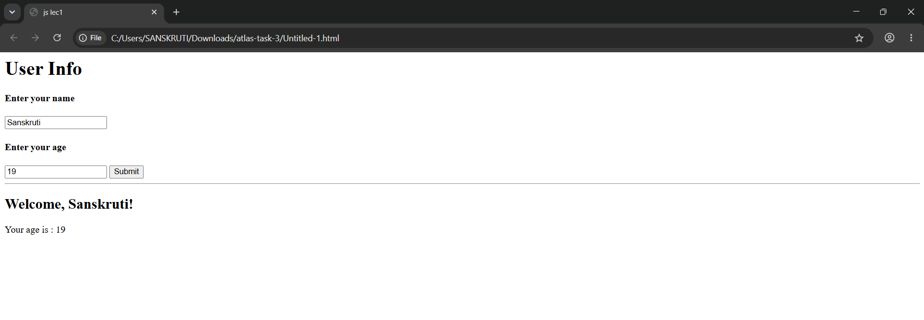
Case Study Title –
Create a webpage for college department and link the student information page with it and write a Java Script Program to Display "Welcome to SIT Nagpur! in an alert Box.

Case Study Program Code –

index.html
<!DOCTYPE html>
<html lang="en">
<head>

<meta charset="UTF-8">
<meta name="viewport" content="width=device-width, initial-scale=1.0">

<title>SIT Nagpur</title>

<style>

*{
margin:0;
padding:0;
box-sizing:border-box;
font-family:Segoe UI,sans-serif;
}

body{
background:#f5f8fc;
}

header{
background:#003366;
color:white;
padding:20px;
display:flex;
justify-content:space-between;
align-items:center;
}

header h1{
font-size:30px;
}

nav a{
color:white;
text-decoration:none;
margin-left:25px;
font-weight:bold;
}

.hero{
height:90vh;
display:flex;
justify-content:center;
align-items:center;
flex-direction:column;
text-align:center;
background:linear-gradient(rgba(0,0,0,.55),rgba(0,0,0,.55)),
url("./infra2.webp");

background-size:cover;
background-position:center;
color:white;
}

.hero h2{
font-size:50px;
margin-bottom:15px;
}

.hero p{
width:70%;
font-size:18px;
line-height:30px;
}

.btn{
margin-top:30px;
padding:15px 35px;
background:#ffb400;
color:#003366;
text-decoration:none;
border-radius:30px;
font-weight:bold;
transition:.3s;
}

.btn:hover{
background:white;
}

.about{

padding:60px;

text-align:center;

}

.cards{

display:flex;

justify-content:center;

gap:25px;

margin-top:35px;

}

.card{

background:white;

width:280px;

padding:25px;

border-radius:15px;

box-shadow:0 10px 20px rgba(0,0,0,.15);

transition:.3s;

}

.card:hover{

transform:translateY(-10px);

}

footer{

background:#003366;

color:white;

padding:20px;

text-align:center;

margin-top:60px;

}

</style>

<script>

window.onload=function(){

alert("Welcome to SIT Nagpur");

}

</script>

</head>

<body>

<header>

<h1>SIT Nagpur</h1>

<nav>

<a href="#">Home</a>

<a href="#">Department</a>

<a href="#">Faculty</a>

<a href="student.html">Student Information</a>

</nav>

</header>

<section class="hero">

<h2>Department of Computer Science & Engineering</h2>

<p>

Providing quality education through innovation, practical learning,

research and industry-oriented curriculum.

</p>

<a href="student.html" class="btn">Student Information</a>

</section>

<section class="about">

<h2>Why Choose Our Department?</h2>

<div class="cards">

<div class="card">

<h3>💻 Modern Labs</h3>

<p>Advanced laboratories with latest software and hardware.</p>

</div>

<div class="card">

<h3>📚 Quality Education</h3>

<p>Experienced faculty and industry-focused curriculum.</p>

</div>

<div class="card">

<h3>🏆 Placements</h3>

<p>Excellent placement opportunities with leading companies.</p>

</div>

</div>

</section>

<footer>

© 2026 SIT Nagpur | Department of Computer Science & Engineering

</footer>

</body>

</html>

student.html

<!DOCTYPE html>
<html lang="en">
<head>

<meta charset="UTF-8">
<meta name="viewport" content="width=device-width, initial-scale=1.0">

<title>Student Information</title>

<style>

*{

margin:0;

padding:0;

box-sizing:border-box;

font-family:Segoe UI,sans-serif;

}

body{

background:#eef4ff;

}

.container{

width:800px;

margin:40px auto;

background:white;

padding:30px;

border-radius:15px;

box-shadow:0 10px 20px rgba(0,0,0,.15);

}

h1{

text-align:center;

margin-bottom:25px;

color:#003366;

}

form{

display:grid;

grid-template-columns:1fr 1fr;

gap:20px;

}

input,select{

padding:12px;

border:1px solid #ccc;

border-radius:8px;

font-size:15px;

}

.full{

grid-column:1/3;

}

button{

grid-column:1/3;

padding:14px;

background:#003366;

color:white;

border:none;

font-size:17px;

border-radius:8px;

cursor:pointer;

}

button:hover{

background:#0056b3;

}

#result{

margin-top:35px;

display:none;

padding:25px;

background:#f5f8fc;

border-radius:10px;

line-height:35px;

}

.back{

display:inline-block;

margin-top:20px;

text-decoration:none;

color:white;

background:#003366;

padding:12px 20px;

border-radius:8px;

}

</style>

</head>

<body>

<div class="container">

<h1>Student Information Form</h1>

<form id="studentForm">

<input type="text" id="name" placeholder="Student Name" required>

<input type="number" id="age" placeholder="Age" required>

<input type="text" id="roll" placeholder="Roll Number" required>

<input type="text" id="dept" placeholder="Department" required>

<input type="text" id="year" placeholder="Year" required>

<select id="gender">

<option>Male</option>

<option>Female</option>

<option>Other</option>

</select>

<input type="email" id="email" placeholder="Email" class="full">

<input type="text" id="phone" placeholder="Phone Number" class="full">

<input type="text" id="address" placeholder="Address" class="full">

<button type="submit">Submit</button>

</form>

<div id="result">

<h2>Student Details</h2>

<p><b>Name:</b> <span id="rname"></span></p>

<p><b>Age:</b> <span id="rage"></span></p>

<p><b>Roll No:</b> <span id="rroll"></span></p>

<p><b>Department:</b> <span id="rdept"></span></p>

<p><b>Year:</b> <span id="ryear"></span></p>

<p><b>Gender:</b> <span id="rgender"></span></p>

<p><b>Email:</b> <span id="remail"></span></p>

<p><b>Phone:</b> <span id="rphone"></span></p>

<p><b>Address:</b> <span id="raddress"></span></p>

</div>

<a href="index.html" class="back">← Back to Home</a>

</div>

<script>

document.getElementById("studentForm").addEventListener("submit",function(e){

e.preventDefault();

document.getElementById("result").style.display="block";

document.getElementById("rname").innerHTML=document.getElementById("name").value;
document.getElementById("rage").innerHTML=document.getElementById("age").value;
document.getElementById("rroll").innerHTML=document.getElementById("roll").value;
document.getElementById("rdept").innerHTML=document.getElementById("dept").value;
document.getElementById("ryear").innerHTML=document.getElementById("year").value;
document.getElementById("rgender").innerHTML=document.getElementById("gender").value;
document.getElementById("remail").innerHTML=document.getElementById("email").value;
document.getElementById("rphone").innerHTML=document.getElementById("phone").value;
document.getElementById("raddress").innerHTML=document.getElementById("address").value;

});

</script>

</body>

</html>

Output –

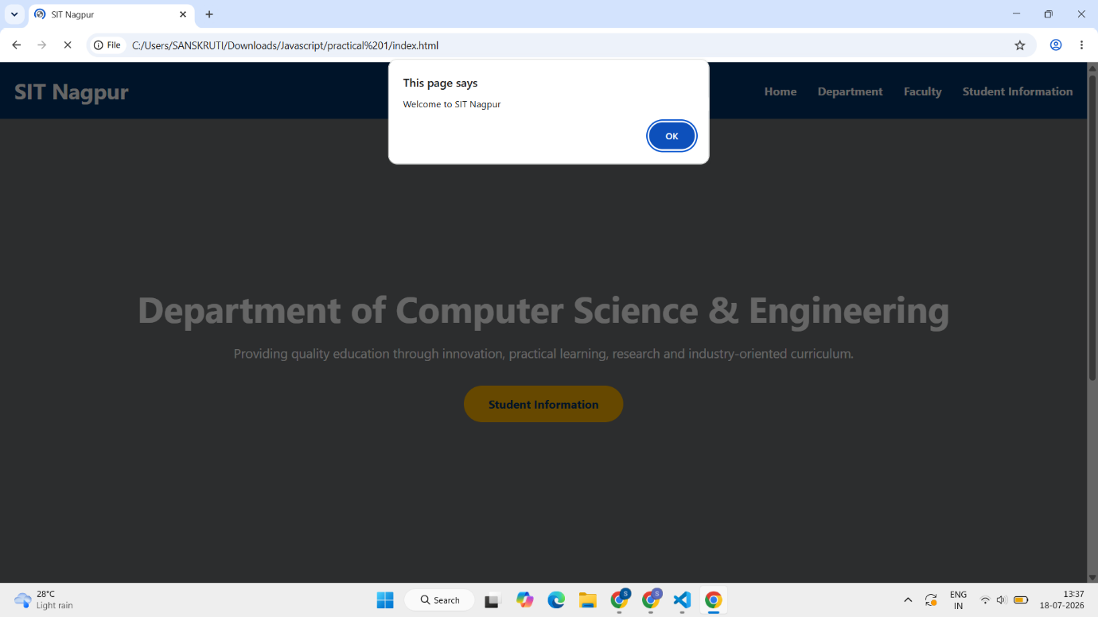

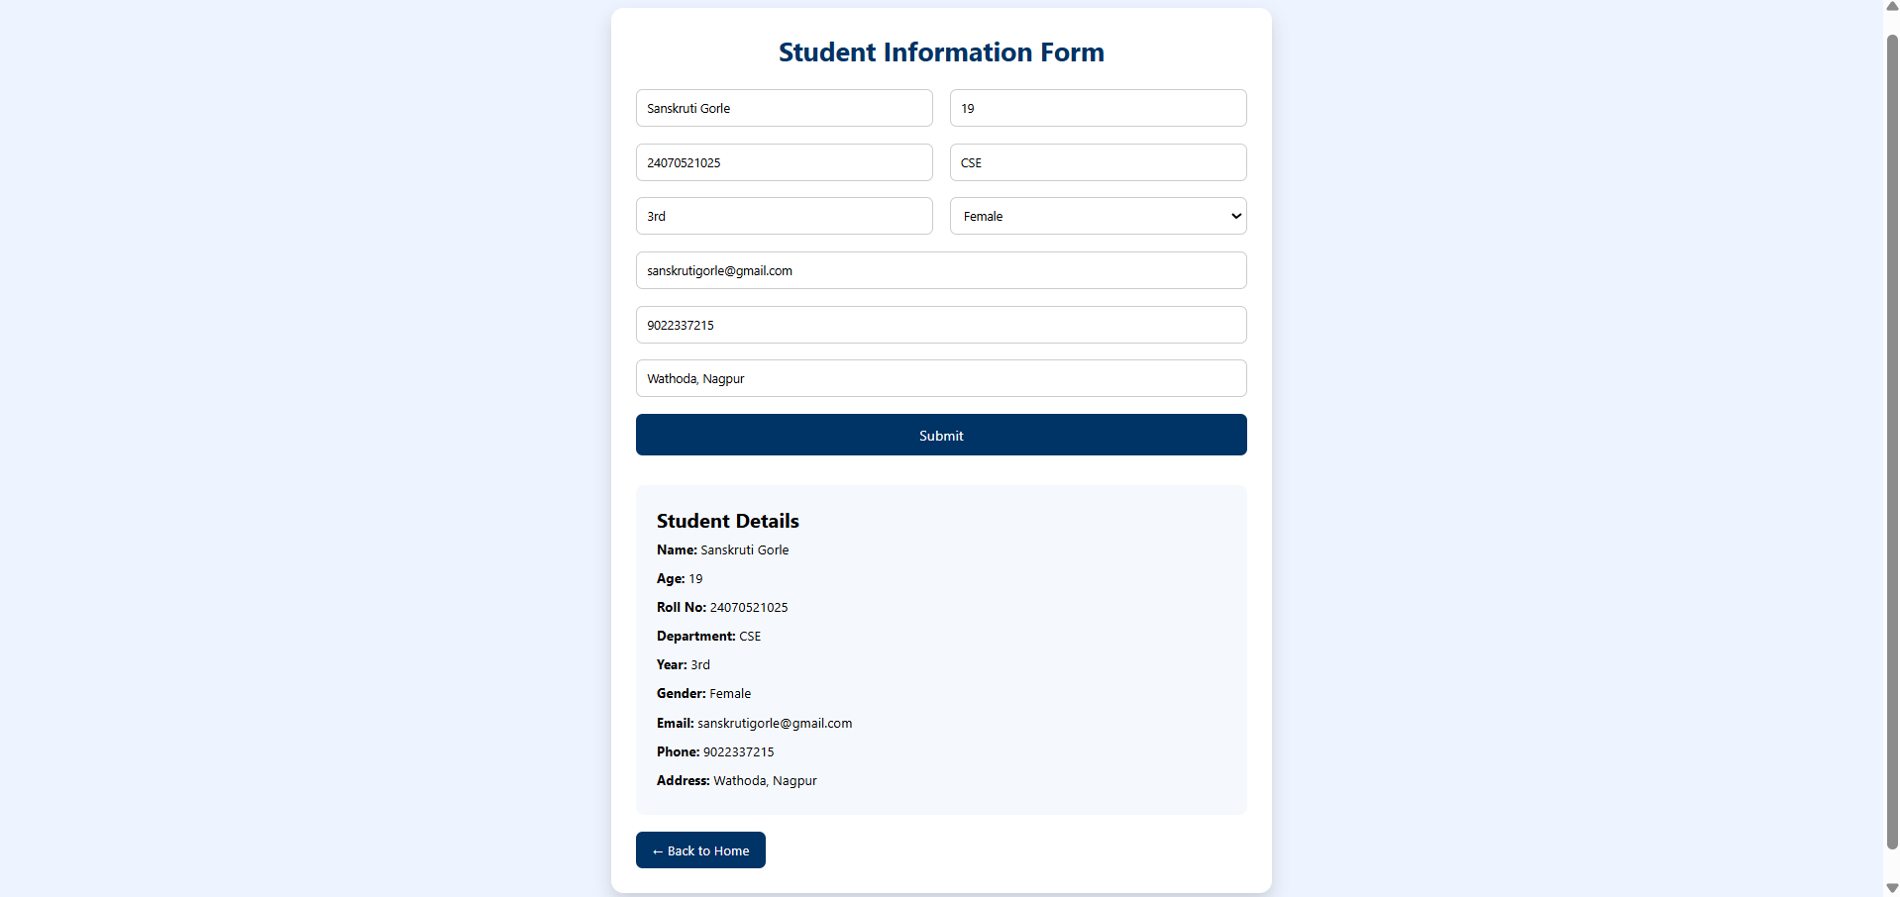

Conclusion –
Thus, the basic concepts of JavaScript were successfully studied and implemented. Different methods of including JavaScript, browser developer tools, console methods, alert boxes, DOM manipulation, and event handling were understood through the development of an interactive web page.

